

ZANZIBAR PLANNING COMMISSION

CAPACITY BUILDING FOR SDGs AND MKUZA III COORDINATION AND REPORTING IN ZANZIBAR

Quarterly Project Progress Report (Quarter 3: July – September 2020)
Project Title: Capacity Building for SDGs and MKUZA III Coordination and Reporting

Country: United Republic of Tanzania

Reference: Agreement signed between ZPC and UNDP

Project Start Date: 01st Sept, 2018

Project End Date: 30th June 2021

Reporting Period: 1st July – 31st September 2019

Overall status of project activities: On-track

INTRODUCTION
The Revolutionary Government of Zanzibar is committed to the implementation of the Global Development Agenda 2030 as reflected in its development programs including the Zanzibar Strategy for Growth and Reduction of Poverty III (MKUZA III). The Zanzibar Planning Commission is being supported by UNDP in implementing a project on ‘Capacity Building for SDGs and MKUZA III Coordination and Reporting in Zanzibar’. The project is aimed at enhancing institutional capacities as well as putting in place an enabling policy and regulatory environment to facilitate coordination, monitoring and reporting of SDGs and MKUZA III. In addition to the ZPC, there is the Implementing Partner (IP), and other key institutions involved in the implementation of this project including Office of the Chief Government Statistician (OCGS), Association of Non- Governmental Organizations in Zanzibar (ANGOZA) and the President Office, Communication Department.

This report is designed to present a detailed narrative of the activities and interventions implemented during the third quarter of 2020 (July -September) in furtherance of the goal and objectives, of the project on ‘Capacity Building for SDGs and MKUZA III Coordination and Reporting in Zanzibar’. During the period under review, planned activities have reached 95% and the focus was mainly on:
  - Effective coordination and strategic leadership on SDGs and MKUZA III data for sustainable development established.
  - Improved national statistical frameworks and systems and
  - Strengthened multi-stakeholder partnerships for sustainable development data.

The following specific activities were implemented, and targets achieved during the quarter under review:

- SIGNIFICANT ACHIEVEMENTS ON AGREED PLANNED ACTIVITIES AND OUTPUTS

OUTPUT 1: Effective Coordination and Strategic Leadership on SDGS and MKUZA III data for sustainable development established.
1.1 Initial meeting of Task Team to agree on SDGs Indicators and working sessions for Drafting 2019/20 Annual SDGs Report.
The meeting has been conducted and lists of Localized SDGs Indicators have been approved to inform the development of annual SDGs implementation report 2019/20.

1.2 Organize Consultative Meeting for Directors of Planning, Policy, and Research (DPPRs), LGAs, Higher Learning Institutions and Private Sectors to discuss the draft of SDGs Roadmap in Zanzibar.
The two days activities involved the Consultation of 120 participants (55 Females; 65 Males), included Directors of Planning Policy and Research, District Administrative Secretaries, Directors for Districts Councils, Private Sectors Coordinators and representatives from Higher Learning Institutions as well as Monitoring and Evaluation Officers from Zanzibar Planning Commission enabled to solicit inputs to feed the respective missing information in the roadmap. The roadmap was then reviewed by the Task team members and incorporated the comments and recommendations that were raised by the participants. Zanzibar Planning Commission has decided to develop a roadmap to SDGs in Zanzibar in order to facilitate and ease coordination in the implementation, monitoring, evaluate and reporting of Sustainable Development Goals and other national, regional and international development commitments to inform policy decisions as well as fulfilling national, regional and international obligations.
It has been emphasized that the roadmap will provide priority actions to support the coordination of the implementation of SDGs across the Islands during the implementation of MKUZA III and MKUZA IV.

The comments and recommendations were as followed:

- Template should be revised whereas the activity should come first followed by output and outcome.
- A column for SDGs should be added to the template for the implementation of roadmap.
- Stakeholders may choose any format out of two that has been raised during the presentation. Either, to start with activity followed by output and outcome or start with outcome, output followed by activity.
- Stakeholders should be taken into consideration that they should put the column of timeline, baseline and targets in the roadmap.
- A key responsible body should be mentioned.
- On the side of cost a column of TZS should be added.
- Paragraph 1 page 8 should be revised against template.
- Table of contents should be completed.

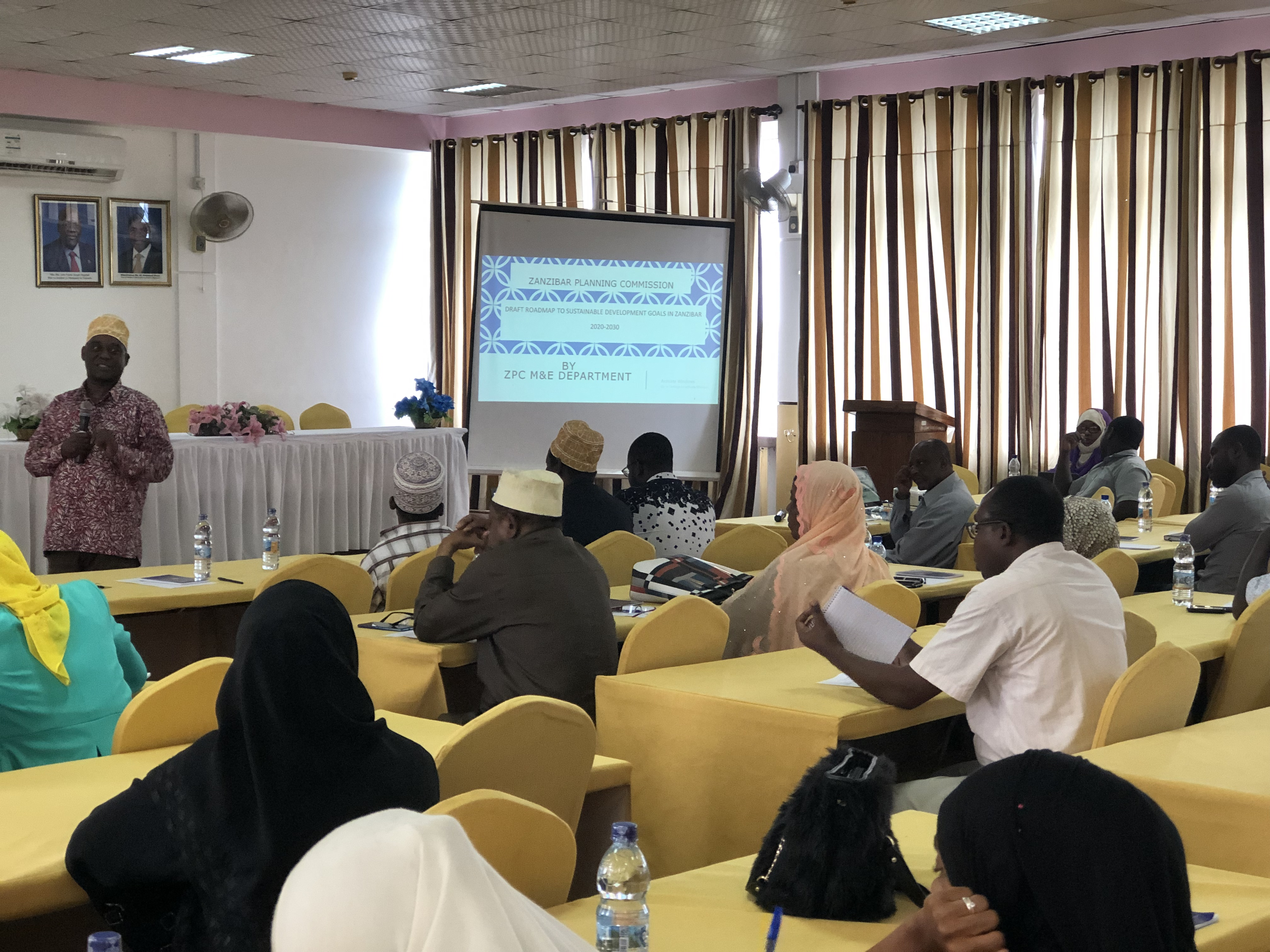
SDGs Coordination Specialist Mr. Kimwaga M. Ali presenting the SDGs Road map at Bima conference in Unguja to the representatives from Private, Sectors, Higher Learning Institutions and CSOs

1.3 Organize Consultative Meeting with the officer’s in charge, Ministry Department and Agents (MDAs), Local Government Authority (LGAs), Higher Learning Institutions, media, Non-state Actors including CSOs and private sectors in Pemba (7- 8 September 2020) to discuss and provide inputs into the draft road map to SDGs in Zanzibar.

The two days activity involved officer’s in charge, MDAs, LGAs, higher learning institutions, media, CSOs and private sectors in Pemba. The objective of the working session was to discuss the draft roadmap to SDGs in Zanzibar. The roadmap aimed at promoting the coordination and balanced integration of the environmental, economic and social dimensions of SDGs through a multi-sectoral partnership that supports the effective pursuit of sustainable development by all MKUZA, SDGs and agenda 2063 stakeholders in Zanzibar. A total of 100 participants (65 Male; 35 Female) have participated.

The objective of the working session was to discuss the draft roadmap to SDGs in Zanzibar. The roadmap aimed at promoting the coordination and balanced integration of the environmental, economic and social dimensions of SDGs through a multi-sectoral partnership that supports the effective pursuit of sustainable development by all MKUZA, SDGs and agenda 2063 stakeholders in Zanzibar. A total of 100 participants (65Male; 35female) have participated.

The meeting facilitated discussions and enabled the roadmap team to solicit inputs and comments from stakeholders. The following issues and challenges were raised:

The delegates made the following comments: -
- The participants wanted to understand how they could report on the SDGs indicators in MKUZA III report as well as wanted more elaboration on the modality of VNR reports which have been submitted to HLPF?
- UNDP Representative also suggested that for those Indicators that have neither baseline nor targets, the ZPC should make use of the proper word, for instance, TBD (To Be Determine) rather than to leave as they are.
- The costs should be in general terms and not per quarter, therefore consider deleting quarter in the draft roadmap
- Baseline and targets should reflect on the national targets i.e. MKUZA III, and therefore include a column for targets and baseline data into the table, and the targets should be distributed in an interval of time e.g. 2025, 2030

RECOMMENDATIONS
The Zanzibar Planning Commission has agreed to review the draft roadmap to SDGs in Zanzibar and include all comments into the draft report. This includes: -
- The Zanzibar Planning Commission has managed to mainstream SDGs into the MKUZA III (Key Results Areas A-E) through a localization process. This has made stakeholders who implement MKUZA III to implement and report on the SDGs at the same time. The M&E guideline for MKUZA III which indictors and roles of every player have also been developed and shared to all stakeholders for their guidance.
- The RGoZ will continue to advocate for the development of national (United Republic of Tanzania) report that contains the Zanzibar and Tanzania Mainland reports
- The Zanzibar Planning Commission will add columns for the Baseline and targets that reflect the national targets i.e. MKUZA III in an interval of time e.g. 2025, 2030
- Zanzibar Planning Commission will review the column on costs and the word quarter will be deleted from the draft roadmap.
- The baseline data and targets that will not have data will be categorized as to be determined (TBD) rather than to leave them as they are.
- The delegates have advised to mainstream the SDGs in their development plans

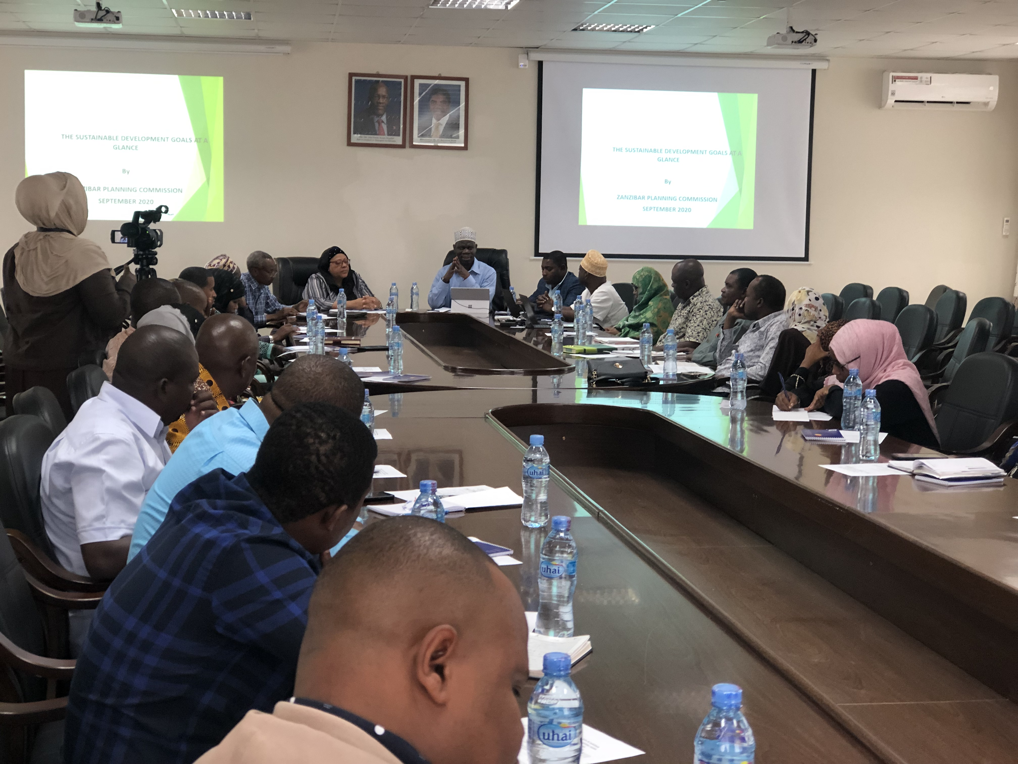
Executive Secretary of ZPC (Mr. Mwita M. Mwita) giving his opening remarks to all Officer-in Charges Pemba, Planning Officers and LGAs on the SDGs Road Map.

1.4 Working session with Ministry Department and Agents (MDAs), Local Government Authority (LGAs), Higher Learning Institutions, media, Non-state Actors including CSOs and private sectors in Unguja (09-10 September 2020) to discuss and provide inputs into the draft of Annual SDGs Report in Zanzibar.

The two days activity involved MDAs, LGAs, higher learning institutions, media, CSOs and private sectors in Unguja. A total of 100 participants (79 Male; 31 female) have participated and provided their comments and recommendations towards the improvement of the draft Annual SDGs implementation report.

COMMENTS
- Maintaining Quality Education is a challenge. Even though the enrollment is performing well but this is only a part of maintaining quality it needs other variables too. An assessment for education sector is needed to improve the quality of education in in Zanzibar.
- Empowerment of people with special needs has been highlighted, and the SDGs team has advised making sure there are Equity and Equality among them at various levels.

- Low skills in entrepreneurship programs and a lack of green housing facilities for youth has also been raised.

- Zanzibar Planning Commission should prepare a Swahili popular version in order to strengthen the knowledge on the implementation of SDGs Goals to Zanzibar local community.

RECOMMENDATIONS
The Consultant has agreed to review the SDGs draft report and include all comments into the draft report. This includes: -
- Zanzibar Planning Commission will prepare a Swahili popular version on the implementation of SDGs Goals in order to strengthen the knowledge to Zanzibar local community.

1.5 Working session with the officer’s in charge, Ministry Department and Agents (MDAs), Local Government Authority (LGAs), Higher Learning Institutions, media, Non-state Actors including CSOs and private sectors in Pemba (11- 12 September 2020) to discuss and provide inputs into the draft of Annual SDGs Report in Zanzibar.

The two days activity which involves officer’s in charge, MDAs, LGAs, higher learning institutions, media, CSOs and private sectors in Pemba. The objective of the working session is to discuss the draft of Annual SDGs Report in Zanzibar. This Annual SDGs report aimed at promoting the coordination and balanced integration of the environmental, economic and social dimensions of SDGs through a multi-sectoral partnership that supports the effective pursuit of sustainable development by all MKUZA, SDGs and agenda 2063 stakeholders in Zanzibar. A total of 100 participants (79 Male; 31 female) have participated.

COMMENTS
- The participants suggest that the report should not only include the areas that are achieved in its implementation but also include areas that not achieved to date.
- UNDP Representative also suggested that for those Indicators that have no baseline but have the current values, the ZPC should use the current values for the purpose to be baseline for next report.
- The participants suggest that there should be conducted a need assessment for education sector in order to know the required skills need in Zanzibar
- Zanzibar Planning Commission should prepare a Swahili popular version in order to strengthen the knowledge on the implementation of SGs Goals to Zanzibar local community
- The participants suggest that due to land scarcity and high demand of land in Zanzibar, the report should clearly show the area of land used for agriculture, residents and other purpose (spatial development).
- The participants suggest that there should conducting a survey/improving routine data system in order to improve availability of data instead of depending only from HBS

RECOMMENDATIONS
The Consultant has agreed to review the SDGs draft report and include all comments into the draft report. This includes: -
- Those Indicators that have no baseline but have the current values, the ZPC should use the current values for the purpose to be baseline for next report .Therefore the baseline column that have no values will remain as they are but will set only a current values.
- The report will recommend conducting research on education sector in order to improve quality education in Zanzibar.
- ZPC has managed to mainstream SDGs into the MKUZA III (Key Results Areas A-E) through a localization process. This has made stakeholders who implement MKUZA III to implement and report on the SDGs at the same time. The M&E guideline for MKUZA III which indictors and roles of every player have also been developed and shared to all stakeholders for their guidance.
- The RGoZ will continue to advocate for the development of national (United Republic of Tanzania) report that contains the Zanzibar and Tanzania Mainland reports
- The Zanzibar Planning Commission will add columns for the Baseline and targets that reflect the national targets i.e. MKUZA III in an interval of time e.g. 2025, 2030
- Zanzibar Planning Commission will review the column on costs and the word quarter will be deleted from the draft roadmap
- The baseline data and targets that will not have data will be categorized as to be determined (TBD) rather than to leave them as they are.
- The delegates have advised to mainstream the SDGs in their development plans
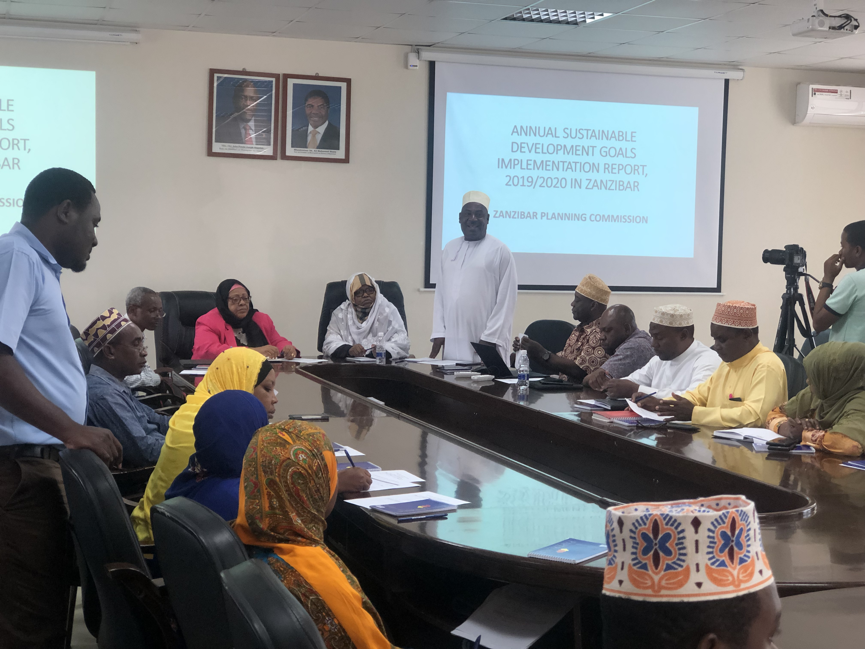
Coordinator of all Officer-in Charges Pemba (Mr Dadi Faki) delivering his Welcoming Note on Annual SDGs Implementation Report 2019/20.

1.6 Working session to finalize SDGs Roadmap.
The two days activity which involves 20 SDGs stakeholders (11 Males, 09 Females) including ZPC, OCGS, MDAs, LGAs, higher learning institutions, media, CSOs and private sectors in Unguja. The objective of the working session is to discuss and finalize the draft roadmap to SDGs in Zanzibar. This Roadmap to SDGs in Zanzibar supports the existing or planned coordination mechanism for the implementation of the 2030 Global Agenda as integral parts of the implementation of MKUZA III and the up-coming MKUZA IV and Vision 2050.

The stakeholders made the following comments: -
- The draft roadmap to SDGs in Zanzibar has accommodated most of the inputs, however, the team should consider planning for baseline indicators surveys for the baseline data and targets that do not have values

RECOMMENDATIONS
The Zanzibar Planning Commission has agreed to review the draft roadmap to SDGs in Zanzibar and include all comments into the draft report. This includes: -
The Zanzibar Planning Commission must make sure that,
- The up-coming national documents reflect on the roadmap to SDGs into their strategies, as this will enhance the reporting of SDGs at all levels.
- There is a review the costs, and those costs are realistic, achievable and are in general terms and not per quarter,
- the baseline and targets should reflect on the national targets i.e. Medium-Term Development Strategy (MTDS)
- There is a plan for the baseline indicator surveys for all data and targets that do not have data and categorized as to be determined (TBD).
- It takes a lead and makes sure that all stakeholders do mainstream the SDGs in their development plans
- It enhances results-based M&E, innovations, research and analytical work that facilitate tracking of progress, identifies challenges of achieving the SDGs, generating relevant SDGs implementation reports and provide evidence-based policy advice among the stakeholders who implement SDGs.

1.7 Validation Meeting for Inputs incorporations to SDGs Roadmap
This is a one-day activity which involves 30 SDGs stakeholders (19Male,11Female) including ZPC, OCGS, MDAs, LGAs, higher learning institutions, media, CSOs and private sectors in Unguja. The objective of the validation meeting is to validate that all comments have been incorporated into the draft SDGs Roadmap.

The delegates have validated the collected information and concluded that: -
- The drafting team have reviewed the draft roadmap to SDGs in Zanzibar and incorporated all comments into the draft roadmap to SDGs in Zanzibar including: -

- using proper words such as TBD to those Indicators that have neither baseline nor targets rather than to leave as they are.
- the costs, which have been reviewed and kept in general terms and not per quarter
- the targets have been reviewed and distributed in an interval of time e.g. 2020, 2025 and 2030
- the baseline and targets have reflected on the national targets i.e. MKUZA III, and a column for targets and baseline data has been included into the table
- All the baseline data has captured from well-known sources such as HBS, 2020, Zanzibar Statistical Abstract 2020, Health bulletin 2018 etc.
- The delegates have also confirmed that the Zanzibar Planning Commission has managed to mainstream SDGs into the MKUZA III (Key Results Areas A-E) through a localization process. The process that made stakeholders who implement MKUZA III to implement and report on the SDGs at the same time and avoid double counting.

RECOMMENDATIONS
- The Zanzibar Planning Commission is advised to print the final version of SDGs Roadmap and distribute it all stakeholders for their use
- The Zanzibar Planning Commission in collaboration with the Development Partners should conduct awareness and training programmes among SDGs stakeholders on how to make use of the SDGs roadmap in their daily activities
- Stakeholders are advised to mainstream the SDGs in their development plans and make use of this roadmap to SDGs in Zanzibar to guide their planning and implementation of their work plans
- The RGoZ through ZPC and in collaboration with the Development Partners must continue to take a lead in raising resources that will support the implementation of SDGs at all levels.

1.8 Dissemination Meeting of Annual SDGs Implementation Report 2019/20.

This is a one-day activity which involves 60 SDGs stakeholders (31Male, 29Female) including ZPC, OCGS, MDAs, LGAs, higher learning institutions, media, CSOs and private sectors in Unguja. The objective of the dissemination meeting is to disseminate the printed version of the Annual SDGs Implementation Report 2019/20. In this meeting, ZPC has highlighted on the roadmap to SDGs in Zanzibar and what ZPC is expected from them.
In this occasion, a total of 600 copies (400 printed copies of a roadmap to SDGs as well as 200 printed copies of annual SDGs implementation Report 2019/20) have been disseminated to stakeholders for their use.

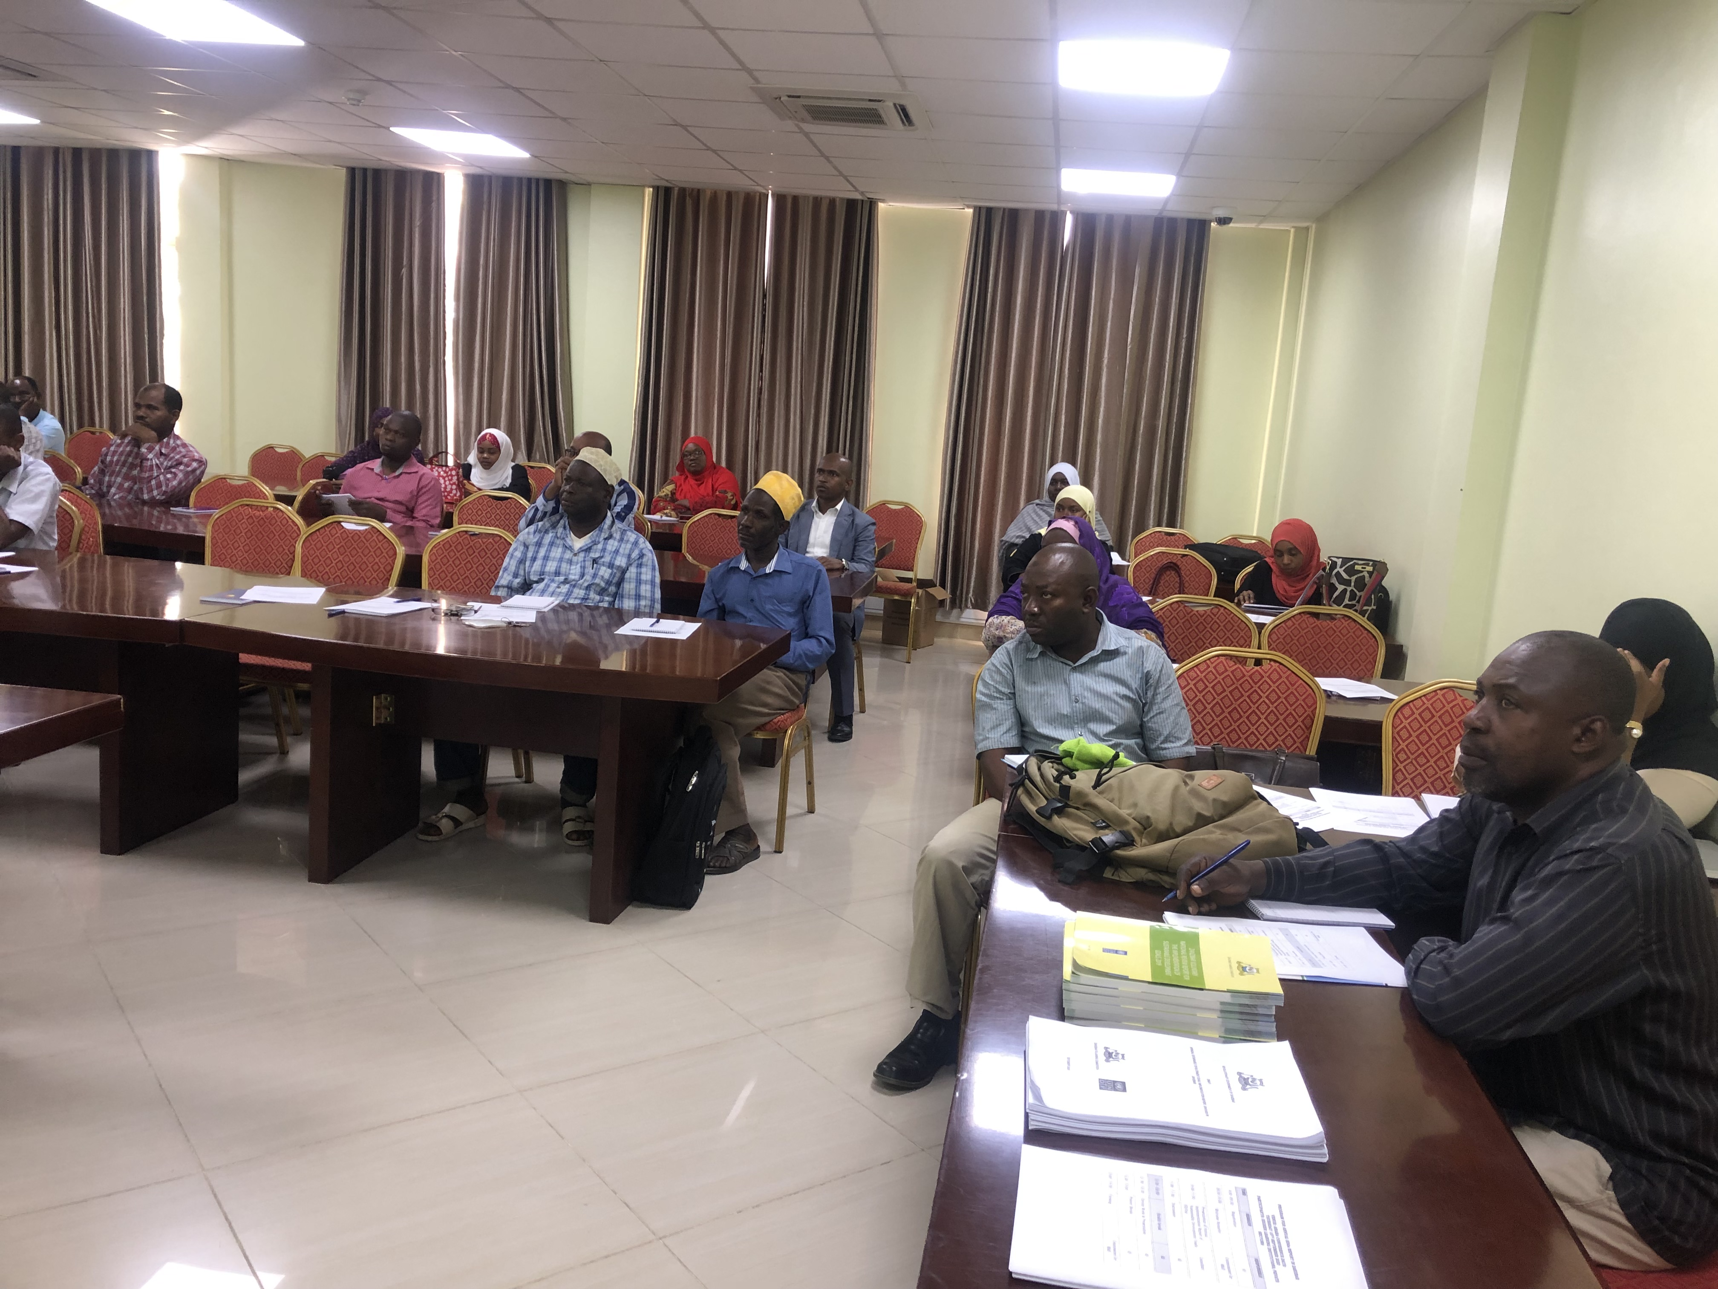

During the dissemination meeting, the stakeholders have also informed that,
- The ZPC in collaboration with UNDP is in the final stages of designing, installing and populating an electronic and operational M&E system with web-based socio-economic database (depository) for ZSGRP, SDGs and agenda 2063 at the Zanzibar Planning Commission (http://www.zpcm&e.og.tz).
- This electronic and operational M&E system with web-based socio-economic database (depository) for ZSGRP, SDGs and agenda 2063 at the Zanzibar Planning Commission will provide the ZPC team with tools to effectively monitor, project progress and achievements in SDGs implementation,
- The stakeholders have also informed that the ZPC will make use of this electronic and operational M&E system with web-based socio-economic database (depository) for ZSGRP, SDGs and agenda 2063 to electronically collect and disseminate SDGs information to all stakeholders.
RECOMMENDATIONS
- The ZPC in collaboration with Development partners supports the establishment of functional platforms for reporting on SDGs indicators as well as SDGs data dissemination at all levels.
- The OCGS, which a national statistics office here in Zanzibar, must become more efficient and self-reliant while expanding statistical capacity in producing SDGs data, measuring the effectiveness of policies and disseminating SDGs data to stakeholders
- The ZPC in collaboration with the Development Partners should continue to ensure that SDGs related data users are provided with new and diversified ways of communicating SDGs information in their areas
- The ZPC in collaboration with the Development Partners to strengthen a results-based M&E system for all relevant indicators to monitor the SDGs and national development plans; and enhance a coordinated approach for collecting collating, interpreting, reporting and disseminating SDGs data at all levels,
- ZPC in collaboration with the Development Partners must support the enhancement of SDGs awareness among Zanzibaris through dialogue, synergies and collaboration among stakeholders including MDAs, public & private sector, Non-State Actors, vulnerable groups etc., in the implementation of various SDGs related interventions at all levels.

Output 2: Improved national statistical frameworks and systems
2.1 Finalize the National Statistics Policy
This activity involved further refinement of the draft National Statistics Policy based on the comments provided by various stakeholders and further consultations with stakeholders of statistics form Unguja, Pemba and Mainland Tanzania. Various community groups from including Government officials, decision makers, policy makers, academia, researchers, private sectors, civil society organizations, politicians and others were consulted independently, and their views have been well articulated at each stage of drafting this policy. The consultations were made for individuals as well as for groups.

Output 3: Strengthened Multi-stakeholder Partnerships for Sustainable Development Data.

3.1 Engagement of CSOs in raising awareness on SDGs and MKUZA III Awareness dialogues to local leaders, CSOs and Religious leaders.
The project seeks to; strengthen multi stakeholder partnerships for sustainable development by creating public awareness and engagement of community and religious leaders and other local stakeholders on the 2030 Agenda for Sustainable Development. In collaboration with Zanzibar Planning Commission ANGOZA conducted SDGs and MKUZA III awareness workshops in 4 districts (Central District, South District, West A District and West B District in Unguja).
The workshops involved a total of 120 (39 Females and 81 Males) local leaders, community and religious leaders, were very effective in creating awareness of community and religious leaders, on MKUZA III and SDGs with the view of enabling them to further advocate for implementation of MKUZA III and Agenda 2030 in their respective communities, whilst underscoring the principle of ‘leaving no one behind’ in the development process.
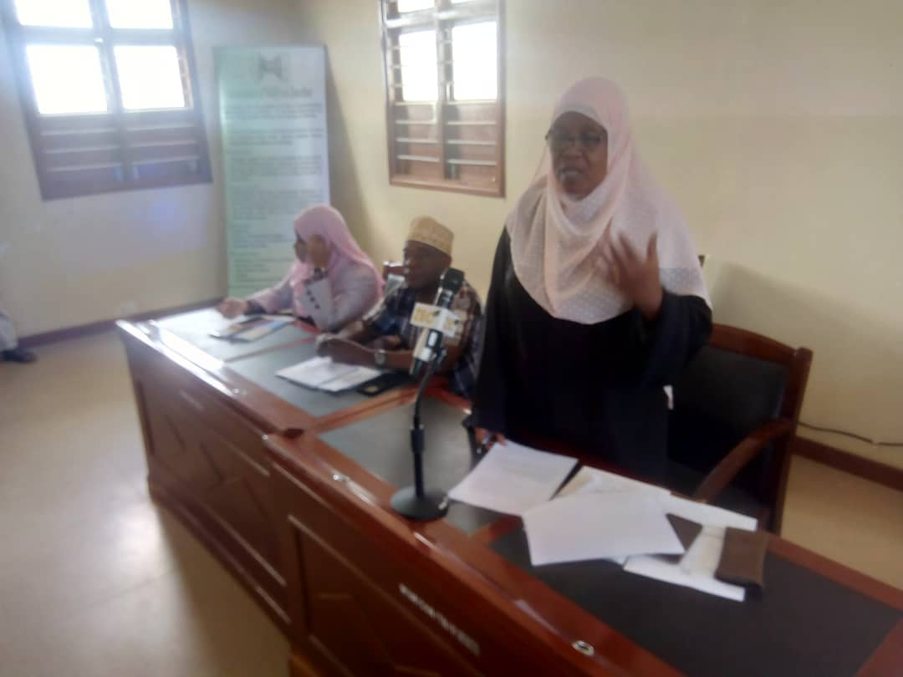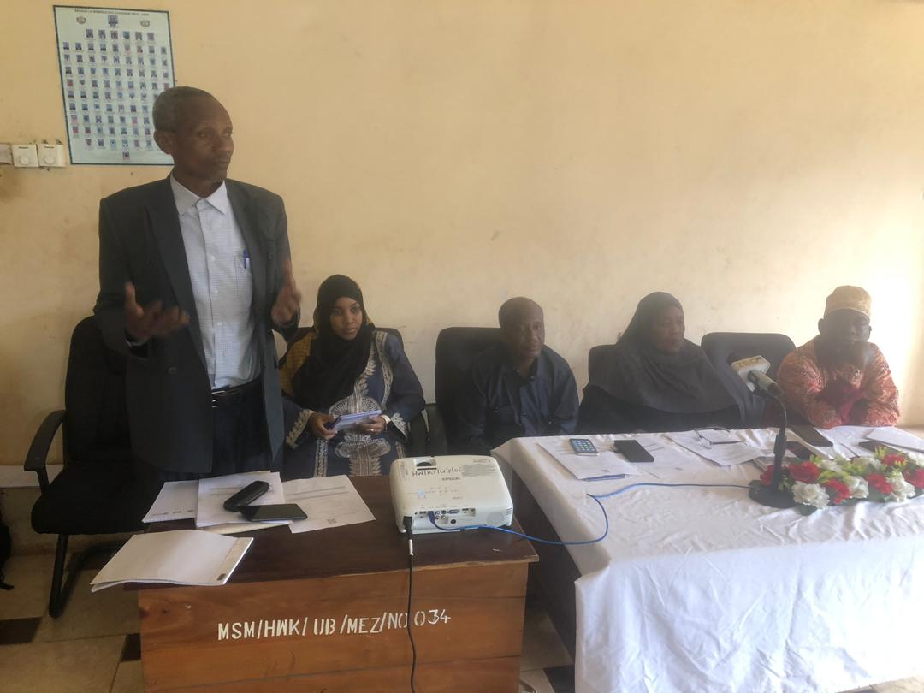
ANGOZA Chairperson Madam Asha Aboud and Representative from UNDP Mr. Ali Shaib presenting their remarks during the working session.

The Presentation which was made by the facilitators was focused on the 17 Sustainable Development Goals and how do they relate to the community; the relationship between SDGs and MKUZA III; as well as the implementation of the SDGs in Zanzibar. The role of community and religious leaders in creating awareness of Agenda 2030 and MKUZA III in their respective communities, was underscored. Discussions ensued and participants indicated their interest on SDGs and commitment in creating awareness of SDGs and MKUZA III to their respective communities through their regular community meetings, Friday religious sermons as well as other forums. It was also brought to attention that such forums are opportunities for the leaders to prioritize their development challenges for further consideration in the development plans of their respective Wards, Shehias and Districts.
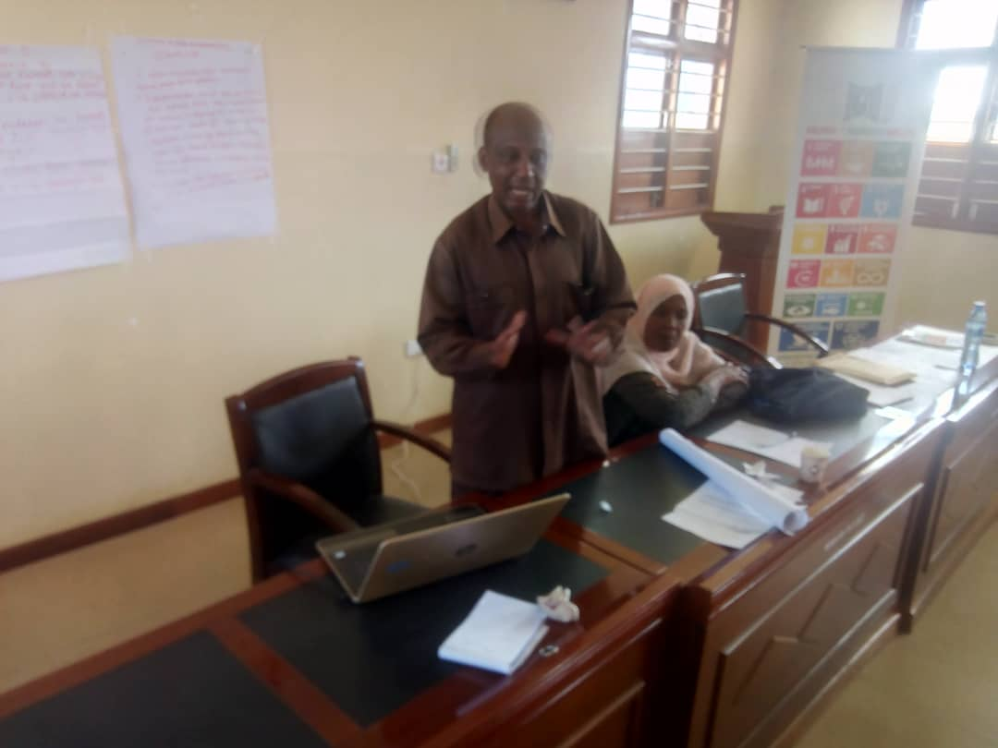
A facilitator from YUNA Mr Ame Haji Vuai and Mr Hassan from ANGOZA presenting the relationship between MKUZA III and SDGs 2020.
From the group presentation Shehas promised to give feedback about training to their members of Shehia Committee and educate them on SDGs and MKUZA III. They also agreed to develop action Plan that addresses challenges related to SDGs and MKUZA III. Religious leaders both Muslims and Christians promised to use different religious forums to disseminate knowledge which they have obtained. Categories of Groups formed by CSOs based on Key result areas of MKUZA III will be used in making follow up the implementation of MKUZA III and SDGs.

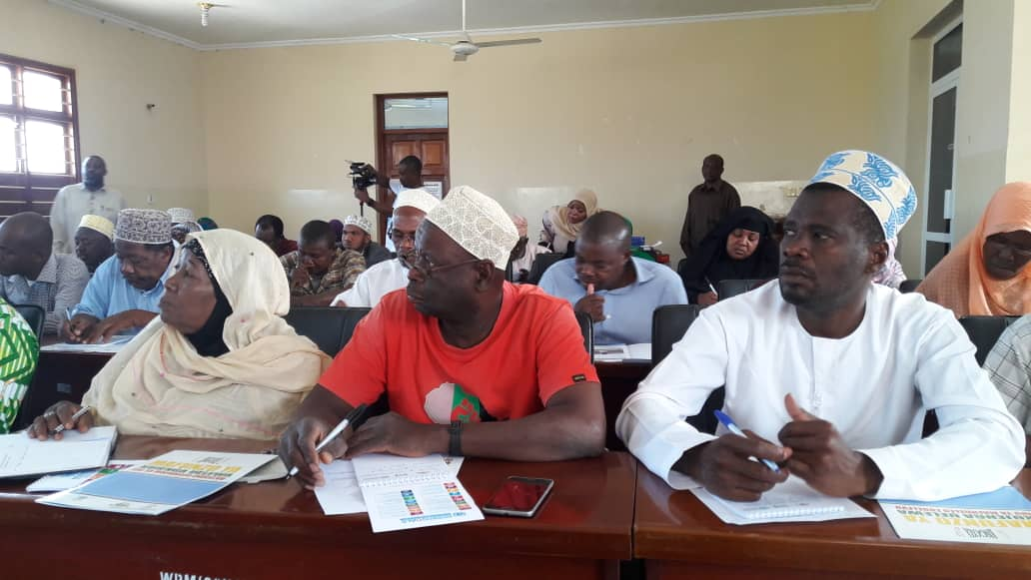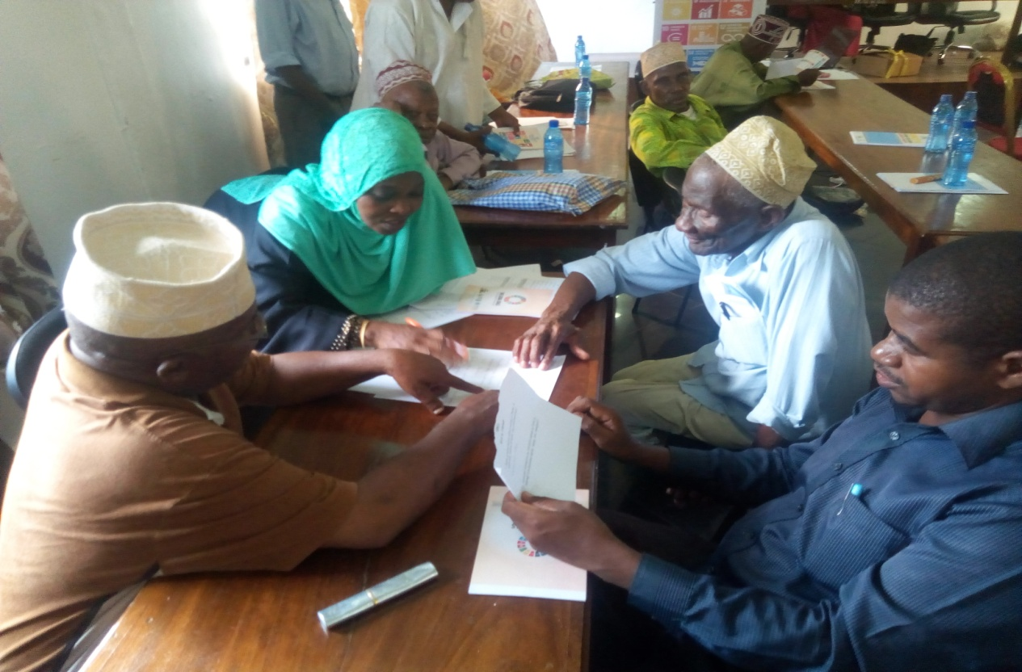
Participants are in group discussion

3.2 Organize Radio/TV program using local and community media houses

Two training seminars were conducted to the community radio staff Unguja and Pemba. The theme of the training based on of Assessment of the Vision 2020, which was facilitated by Zanzibar Planning Commission. Overall 60 media professionals were presented. For Pemba the two days seminar was conducted on 21st to 22nd, August 2020. And for Unguja the seminar took place on 25th, to 26th, August 2020. The invited community radios station in Pemba were Mkoani FM Radio and Micheweni Community Radio, while Mtegani FM Redio, Redio Tumbatu and Binguni FM Redio participated in Unguja . Other media presented were ZBC TV, ZBC Radio, and Zanzibar Leo Newspaper, Alnoor radio Station, Cable Tv and Government Information Department. The massive participation of our media houses on seminar in Unguja and Pemba provided a wide media coverage on the Assessment of the Vision 2020.
At the end of the seminar all participants were assigned to produce at least one program and or news article regarding the implementation of version 2020 and broadcast via their radio stations.
Article writing
With the support from Zanzibar Planning Commission, the State House Department of Communication and information has facilitated various independent media professionals on writing and publishing different articles in their respective media about vision 2020. The selected media for this quarter were the Daily news, Daily Mail and Zanzibar Leo newspaper.
On 9th September, 2020 the Daily News published an article titled ‘Zanzibar Eyes Sea – Bridges to Link small Isles’. The article is available on the dailynews.co.tz/news/2020-09-085f57a7f530dd8.aspx. Another article titled ‘Zanzibar Celebrates Concluding Vision 2020 with Success’ was also published in the Daily News on 2nd September 2020. It is also available at dailynews.co.tz/news/2020-09-015f4e64b4a7a8f.aspx
On the Government English Newspaper - Zanzibar Mail different articles on Vision 2020 was published on September 7th, 2020. All feature articles mainly based on the achievements of Vision 2020 and the success of His Excellency Hon. Dr. Ali Mohamed Shein in his ten years of Presidency. The articles are titled as follows;-
Pg 6 ‘Tarmac roads ease transport’.
Pg 8 ‘Pemba Islets Have Reasons to Rejoice’
Pg 10 ‘Vision 2020 Elevates Zanzibar to Lower – Middle Income Status’.
On the Government Swahili Newspaper – “Zanzibar Leo” an article, which carries the massage on the achievements of Vision 2020 titled ‘Serikali imefanikiwa kutekeleza Dira 2020’, was published on 30th August 2020.
Radio programs
In collaboration with the community radios, eight (8) radio programs produced and aired via six radio stations. The program based on the implementation of MKUZA III as well as performance of the 7th phase of the Revolutionary Government under the leadership of H.E Hon. Dr. Ali Mohamed Shein.
The program explore development in different sectors including education, Health issues on Mother and Child health, Covid 19, Agriculture and infrastructure.
The production of these radio programs is a result of the given task to the stations on which radio stations were assigned to produce four programs featuring the achievements and challenges of MKUZA III and the implementation of Vision 2020. The task was well implemented as eight programs were submitted to the office. All programs are available on the following You Tube link:-
https://www.youtube.com/watch?v=VPHY-ufiq2w&feature=youtu.be

https://www.youtube.com/watch?v=_XlIsVETObM&feature=youtu.be

https://www.youtube.com/watch?v=MkURsan_hdA&feature=youtu.be

https://www.youtube.com/watch?v=yRkHQe3gH6Q&feature=youtu.be
https://www.youtube.com/watch?v=zF4OA2ujWqQ&feature=youtu.be
https://www.youtube.com/watch?v=2xXc9ZhjLIE&feature=youtu.be
https://www.youtube.com/watch?v=0EL5_tVdhXM&feature=youtu.be
https://www.youtube.com/watch?v=0EL5_tVdhXM&feature=youtu.be
https://www.youtube.com/watch?v=Kfb6N6oyN_o&feature=youtu.be
https://www.youtube.com/watch?v=OzBSokuhKSk&feature=youtu.be

3. Challenges:
Delay of the disbursement of fund which has been experienced since the commencement of the project is remaining a challenge for the project implementation.
4. Disbursement.
A total of TZS 125,569,643 (equivalent to USD 54,860) was disbursed to the IPs and 86% have been expended during the quarter review.

RESULTS MATRIX
Outcome : Strengthened Institutional Capacities in the Implementation, Monitoring and Reporting of SDGs and MKUZA III in Zanzibar
Output | Planned Activity for Q3 | Progress | Comments
Output1: Effective coordination and strategic leadership on SDGs and MKUZA III data for sustainable development established  Engagement with donor partners | 1.1 Initial meeting of Task Team to agree on SDGs Indicators and working sessions for Drafting 2019/20 Annual SDGs Report. | completed | Task Team to agree on SDGs Indicators and working sessions for Drafting 2019/20 Annual SDGs Report was conducted.
 | 1.2 Organize Consultative Meeting for Directors of Planning, Policy, and Research (DPPRs), LGAs, Higher Learning Institutions and Private Sectors to discuss the draft of SDGs Roadmap in Zanzibar. | Completed | The two days activities involved the Consultation of 120 participants (55 Females; 65 Males), included Directors of Planning Policy and Research, District Administrative Secretaries, Directors for Districts Councils, Private Sectors Coordinators and representatives from Higher Learning Institutions.
 | 1.3 Organize Consultative Meeting with the officer’s in charge, Ministry Department and Agents (MDAs), Local Government Authority (LGAs), Higher Learning Institutions, media, Non-state Actors including CSOs and private sectors in Pemba (7- 8 September 2020) to discuss and provide inputs into the draft road map to SDGs in Zanzibar. | Completed | The activity involved the discussion of the roadmap which aimed at promoting the coordination and balanced integration of the environmental, economic and social dimensions of SDGs through a multi-sectoral partnership that supports the effective pursuit of sustainable development by all MKUZA, SDGs and agenda 2063 stakeholders in Zanzibar. A total of 100 participants (65 Male; 35 Female) have participated.
 | 1.4 Working session with Ministry Department and Agents (MDAs), Local Government Authority (LGAs), Higher Learning Institutions, media, Non-state Actors including CSOs and private sectors in Unguja (09-10 September 2020) to discuss and provide inputs into the draft of Annual SDGs Report in Zanzibar. | Completed | A total of 100 participants (79 Male; 31 female) have participated and provided their comments and recommendations towards the improvement of the draft Annual SDGs implementation report.
 | 1.5 Working session with the officer’s in charge, Ministry Department and Agents (MDAs), Local Government Authority (LGAs), Higher Learning Institutions, media, Non-state Actors including CSOs and private sectors in Pemba (11- 12 September 2020) to discuss and provide inputs into the draft of Annual SDGs Report in Zanzibar. | Completed | A total of 100 participants (79 Male; 31 female) have participated and provided their comments and recommendations towards the improvement of the draft Annual SDGs implementation report.
 | 1.6 Working session to finalize SDGs Roadmap. | Completed | The two days activity which involves 20 SDGs stakeholders (11 Males, 09 Females) including ZPC, OCGS, MDAs, LGAs, higher learning institutions, media, CSOs and private sectors in Unguja. The objective of the working session is to discuss and finalize the draft roadmap to SDGs in Zanzibar.
 | 1.7 Validation Meeting for Inputs incorporations to SDGs Roadmap | Completed | The drafting team have reviewed the draft roadmap to SDGs in Zanzibar and incorporated all comments into the draft roadmap to SDGs in Zanzibar including.  The activity involved 30 SDGs stakeholders (19Male, 11Female) including ZPC, OCGS, MDAs, and LGAs, higher learning institutions, media, CSOs and private sectors in Unguja.
 | 1.8 Dissemination Meeting of Annual SDGs Implementation Report 2019/20. | Completed | A total of 600 copies (400 printed copies of a roadmap to SDGs as well as 200 printed copies of annual SDGs implementation Report 2019/20) have been disseminated to stakeholders for their use.
Output2: Improved national statistical frameworks and systems | Finalize the National statistics Policy | On progress | This activity involved further refinement of the draft National Statistics Policy based on the comments provided by various stakeholders and further consultations with stakeholders of statistics form Unguja, Pemba and Mainland Tanzania.
Output3: Strengthened Multi-stakeholder Partnerships for Sustainable Development Data | 3.1 Engagement of CSOs in raising awareness on SDGs and MKUZA III Awareness dialogues to local leaders, CSOs and Religious leaders. | Completed | The workshops involved a total of 120 (39 Females and 81 Males) local leaders, community and religious leaders, were very effective in creating awareness of community and religious leaders, on MKUZA III and SDGs with the view of enabling them to further advocate for implementation of MKUZA III and Agenda 2030 in their respective communities, whilst underscoring the principle of ‘leaving no one behind’ in the development process.
 | 3.2 Organize Radio/TV program using local and community media houses | Completed | A total of eight (8) MKUZA/SDGs awareness campaigns programmes were aired through Mkoani FM Radio and Micheweni Community Radio in Pemba, while Mtegani FM Redio, Redio Tumbatu and Binguni FM Redio in Unguja . Other media presented were ZBC TV, ZBC Radio, and Zanzibar Leo Newspaper, Alnoor radio Station, Cable Tv and Government Information Department. Community Radios in Unguja and Pemba.  Reports and IEC material on SDGs/MKUZA have been produced and disseminated.

